**Industrial Internship Report on**

**” Street Light Monitering System**

**With Distance Senser ”**

**Prepared by**

**[Ritesh Kumar]**

An Intern in UpSkill Campus, 26/07/2023

|  |
| --- |
| *Executive Summary* |
| This report provides details of the Industrial Internship provided by upskill Campus and The IoT Academy in collaboration with Industrial Partner UniConverge Technologies Pvt Ltd (UCT).  This internship was focused on a project/problem statement provided by UCT. We had to finish the project including the report in 6 weeks’ time.  My project was Street Light Monitoring System with Distance Senser. The Street Light Monitoring System uses distance sensors to detect nearby activity. It optimizes energy usage, improves safety, and reduces light pollution.  This internship gave me a very good opportunity to get exposure to Industrial problems and design/implement solution for that. It was an overall great experience to have this internship. |

**TABLE OF CONTENTS**

1 Preface 3

2 Introduction 5

2.1 About UniConverge Technologies Pvt Ltd 5

2.2 About upskill Campus 10

2.3 Objective 12

2.4 Reference 12

2.5 Glossary 12

3 Problem Statement 13

4 Existing and Proposed solution 14

5 Proposed Design/ Model 16

5.1 High Level Diagram (if applicable) 17

5.2 Low Level Diagram (if applicable) 18

5.3 Interfaces (if applicable) 18

6 Performance Test 20

6.1 Test Plan/ Test Cases 20

6.2 Test Procedure 22

6.3 Performance Outcome 22

7 My learnings 23

8 Future work scope 25

# Preface

Combining multiple technologies, such as Android app development, IoT (Internet of Things) devices, and communication protocols, is required to create an Android streetlight monitoring system. Remote streetlight status monitoring and effective management are the objectives. An overview of the major steps in developing such a system is given below:

1. Hardware Setup:

Install IoT hardware, such as sensors or microcontrollers, on every streetlight. These gadgets should be able to determine whether a streetlight is on or off, gather data, and communicate with an Android app online. For my project, I utilised an Arduino Uno and an ultra sensor.

1. Server Setup:

Server configuration: Install a cloud server to gather and store data from IoT devices. In order to use Firebase setup, the server needs to be able to handle incoming data from LED streetlights and store it in a database.

1. Android App Development:

Currently, Android app development creating an Android app to use as the monitoring system's user interface. Each streetlight should be able to be monitored and managed remotely by users.

1. Real-time Data Retrieval:

In this step, I set up the Android app to follow the Arduino uno codes, which are where IoT devices post their status information. This allows the app to get real-time updates regarding the status of the distance sensor and streetlight LED.

1. Status Display:

Next, I designed the app's user interface to show each streetlight's LED state (on/off) with a different colour button for simple visualisation.

1. Remote Control:

A feature that enables users to remotely control the LED streetlights has been added to the Android app. This can entail switching them on and off.

1. Testing and Deployment:

Ensure smooth connection between the Android app, server, and IoT devices by thoroughly testing it. After testing, publish the app on Google Play or make it available to the intended audience.

Last but not least, make sure that user data is safeguarded and communication between the Android app and the server is encrypted. Checking for scalability to support an increase in the quantity of users and lamps in the future.

By providing hands-on experience and useful expertise in mobile app development, an Android internship is essential for career advancement. Aspiring developers can experience cooperation, real-world projects, and industry best practices by participating in internships. It offers the chance to work with knowledgeable mentors, improving technical abilities and encouraging creativity. Android internships enable people to lay a solid foundation for a fruitful career in the rapidly changing field of mobile technology.

The "Street Light Monitoring System" with a distance sensor would be implemented on Android by creating a mobile application that communicates with the distance sensor and offers functions for controlling and monitoring the street lights.

As an Android development intern, it was a fantastic opportunity to work in a broad and dynamic field. To produce a reliable and efficient solution, the development process would entail cooperation between Android app developers, sensor experts, and system integrators.

How Program was planned



It was a fantastic opportunity for me because Android programming is a flexible and dynamic industry. I appreciate you providing me with the chance to design cutting-edge mobile applications that meet a variety of my needs and improve my entire experience.

Thanks to all (my mentor and guide Pranay Sir and Vipul Sir), who have helped you directly or indirectly.

Dear juniors and peers,

I wanted to tell you about my internship in Android development. It has been a wonderful adventure that has enriched my talents and opened up several prospects in the computer business. During the internship, I got practical information, worked on real-world projects, and cooperated with experienced mentors, which considerably increased my confidence and expertise in Android development.

I strongly advise you to consider taking an Android internship. It will be an excellent experience that will not only improve your technical talents but also provide the groundwork for a successful career in the mobile app development area. Accept challenges, keep interested, and never stop learning. Let us make the most of this exciting and ever-changing world together of Android Development.

Best wishes

Ritesh Kumar (9330771068)

Email: kumarritesh6769@gmail.com

# Introduction

## About UniConverge Technologies Pvt Ltd

A company established in 2013 and working in Digital Transformation domain and providing Industrial solutions with prime focus on sustainability and RoI.

For developing its products and solutions it is leveraging various**Cutting Edge Technologies e.g. Internet of Things (IoT), Cyber Security, Cloud computing (AWS, Azure), Machine Learning, Communication Technologies (4G/5G/LoRaWAN), Java Full Stack, Python, Front end**etc.



1. UCT IoT Platform **(****)**

**UCT Insight** is an IOT platform designed for quick deployment of IOT applications on the same time providing valuable “insight” for your process/business. It has been built in Java for backend and ReactJS for Front end. It has support for MySQL and various NoSql Databases.

* It enables device connectivity via industry standard IoT protocols - MQTT, CoAP, HTTP, Modbus TCP, OPC UA
* It supports both cloud and on-premises deployments.

It has features to  
• Build Your own dashboard  
• Analytics and Reporting  
• Alert and Notification  
• Integration with third party application(Power BI, SAP, ERP)  
• Rule Engine

 

1. **Smart Factory Platform (****)**

Factory watch is a platform for smart factory needs.

It provides Users/ Factory

* with a scalable solution for their Production and asset monitoring
* OEE and predictive maintenance solution scaling up to digital twin for your assets.
* to unleased the true potential of the data that their machines are generating and helps to identify the KPIs and also improve them.
* A modular architecture that allows users to choose the service that they what to start and then can scale to more complex solutions as per their demands.

Its unique SaaS model helps users to save time, cost and money.

 

1.  based Solution

UCT is one of the early adopters of LoRAWAN teschnology and providing solution in Agritech, Smart cities, Industrial Monitoring, Smart Street Light, Smart Water/ Gas/ Electricity metering solutions etc.

1. Predictive Maintenance

UCT is providing Industrial Machine health monitoring and Predictive maintenance solution leveraging Embedded system, Industrial IoT and Machine Learning Technologies by finding Remaining useful life time of various Machines used in production process.



## About upskill Campus (USC)

upskill Campus along with The IoT Academy and in association with Uniconverge technologies has facilitated the smooth execution of the complete internship process.

USC is a career development platform that delivers **personalized executive coaching** in a more affordable, scalable and measurable way.



Seeing need of upskilling in self paced manner along-with additional support services e.g. Internship, projects, interaction with Industry experts, Career growth Services

<https://www.upskillcampus.com/>

upSkill Campus aiming to upskill 1 million learners in next 5 year



## The IoT Academy

The IoT academy is EdTech Division of UCT that is running long executive certification programs in collaboration with EICT Academy, IITK, IITR and IITG in multiple domains.

## Objectives of this Internship program

The objective for this internship program was to

 ☛ get practical experience of working in the industry.

 ☛ to solve real world problems.

 ☛ to have improved job prospects.

 ☛ to have Improved understanding of our field and its applications.

 ☛ to have Personal growth like better communication and problem solving.

## Reference

* <https://developer.android.com/studio>
* <https://developer.android.com/>
* <https://www.upskillcampus.com/>
* <https://www.geeksforgeeks.org/>

## Glossary

|  |  |
| --- | --- |
| Terms | Acronym |
| UCT | UniConverge Technologies Pvt Ltd |
| IITK | Indian Institute of Technology Kanpur |
| IITR | Indian Institute of Technology Roorkee |
| IITG | Indian Institute of Technology Guwahati |

# Problem Statement

In the assigned problem statement

A "Street Light Monitoring System" with a distance sensor is mentioned in the problem description. This technology is most likely intended to monitor and operate street lights more efficiently and automatically.

Based on the data collected from the distance sensor, the system's goal could be to modify the lighting intensity or time of the street lights. If the distance sensor detects no activity or traffic in a specific area, for example, the system may dim or turn off the street lights to save energy. When the distance sensor senses movement, it may boost the brightness or activate extra lights to guarantee adequate visibility and safety.

**Develop a project related to the Street Light Monitoring System in form of Android Application.**

# Existing and Proposed solution

To create an IOT project for a smart street light, you must:

* Select an IOT platform. IOT platforms come in a wide variety, each with unique advantages and disadvantages. AWS IOT, Azure IOT Suite, and Google Cloud IOT Core are a few of the more well-known platforms. These systems offer IOT devices scalable, secure, and dependable connectivity. Additionally, they provide a range of tools for creating, implementing, and administering IOT systems.
* Plan the architecture of the system. This includes figuring out how the system's various parts will communicate with one another. Scalability, dependability, and security should all be built into the system architecture.
* Build the equipment. This applies to both the actual street light and any sensors or actuators you want to use. The street light must be able to send and receive data, as well as have a mechanism to connect to the internet. It will be necessary for the sensors and actuators to be able to gather environmental data and adjust the street light accordingly.
* Combining LORAWAN and MQTT. A common machine-to-machine (M2M) communications protocol is MQTT, which is small and lightweight. Low-power wide-area network (LPWAN) technology called LORAWAN is made for long-distance communications and uses less power. You may build a system that can gather data from sensors and transmit it to a remote location by combining MQTT and LORAWAN.
* Make the mobile application. Users will be able to remotely control the street light using the mobile app. It must be able to connect to the IOT platform and communicate with the street light using commands. Additionally, data from the sensors will need to be shown.
* Install your system. You must deploy your system once all of its components have been developed. This entails installing the hardware, configuring the IOT platform, and launching the mobile app.

Data will be processed, sent to the mobile app, and stored on the server/cloud. The street light can also be remotely controlled using the server/cloud.

Here are some more specifics regarding how MQTT and LORAWAN are combined:

* MQTT is a lightweight and effective publish/subscribe communications protocol that is perfect for IOT applications.
* Low-power wide-area network (LPWAN) technology called LORAWAN is made for long-distance communications and uses less power.
* You can build a system that can gather data from sensors and transfer it to the cloud by combining MQTT with LORAWAN.

The data can then be used by the cloud to produce reports, spot issues, and monitor patterns of energy use.

**Required Functionalities:**

* Allow users to regulate the street light in a number of different ways. This can involve turning on and off the light.
* Permit users to access sensor data. This might contain measurements of distance.

**Software Required**:-

The software you may use in building the project is mentioned below:-

* Mobile front-end: Swift (for iOS), Java (for Android), React Native, Flutter, etc.
* Back end: Node.js , Python , Java, etc.
* Database Technologies: Use a cloud-based database
* External Service/API Integration: Weather APIs, Water Quality APIs, IOT device APIs if needed.
* Data Visualization Libraries: ECharts , High charts ,Google Charts.

Anyone who wishes to regulate their streetlights and conserve energy can benefit from using the control streetlight website.

## Code submission (Github link)

## <https://github.com/RiteshKumar1331/UpSkill-Campus-Internship-Report>

## Report submission (Github link)

## <https://github.com/RiteshKumar1331/UpSkill-Campus-Internship-Report>

# Proposed Design/ Model

1. A system that monitors and regulates street lights is referred to as a "street light monitoring system." To accomplish its goals, it might incorporate a range of sensors, control systems, and communication modules.
2. Distance Sensor: A distance sensor is built into the system. This kind of sensor measures the distances of nearby objects or obstacles. The distance sensor could be used in the Street Light Monitoring System to look for cars, people walking along the sidewalk or any other items close to the street lights.

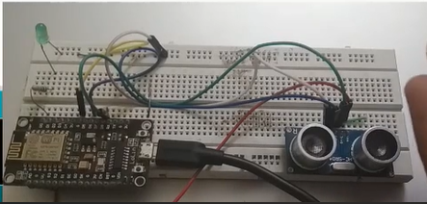

Arduino uno

Off LED

Ultra sensor

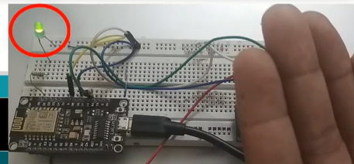

On LED

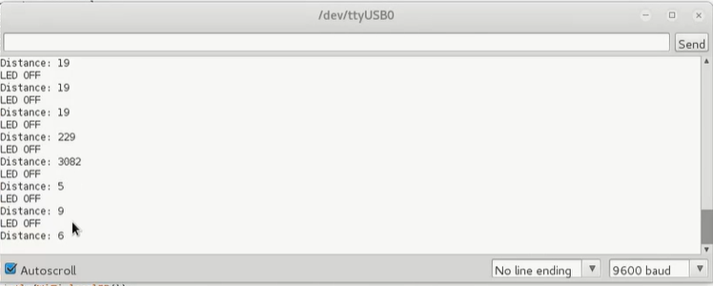

## High Level Diagram (if applicable)

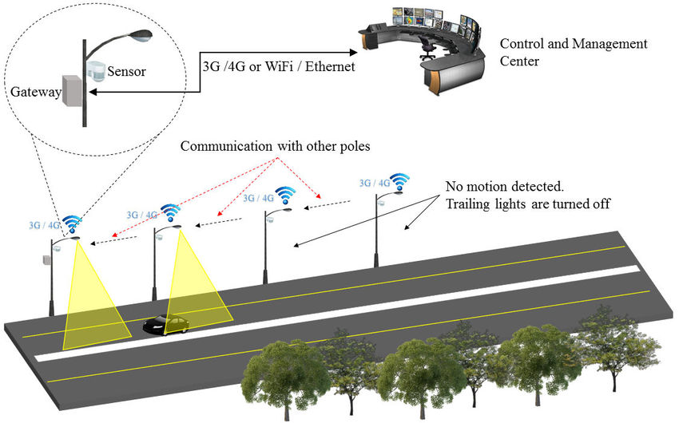

Figure 1: HIGH LEVEL DIAGRAM OF THE SYSTEM

## Low Level Diagram (if applicable)

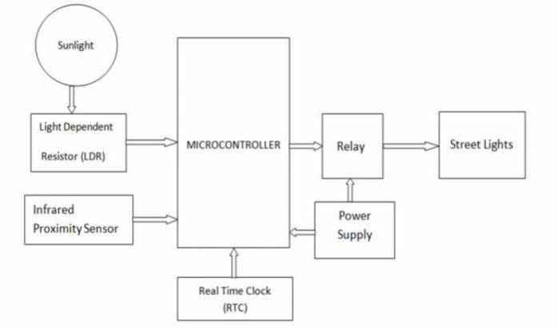

## Interfaces (if applicable)

Update with Block Diagrams, Data flow, protocols, FLOW Charts, State Machines, Memory Buffer Management.

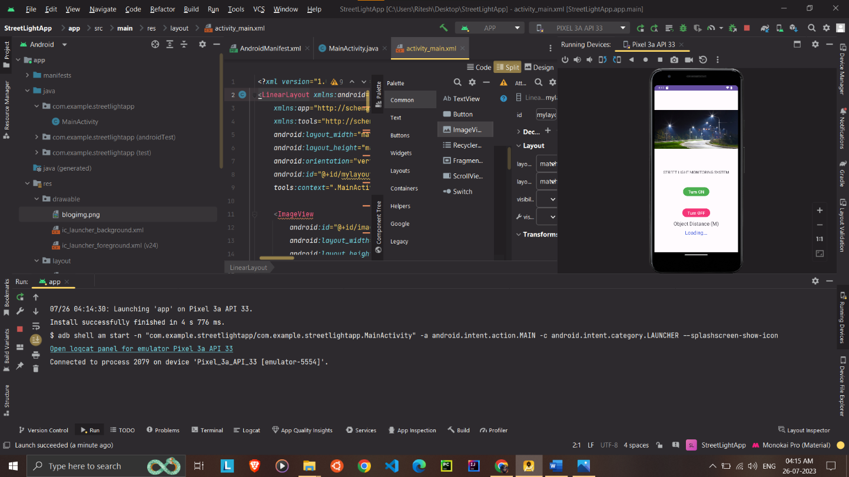

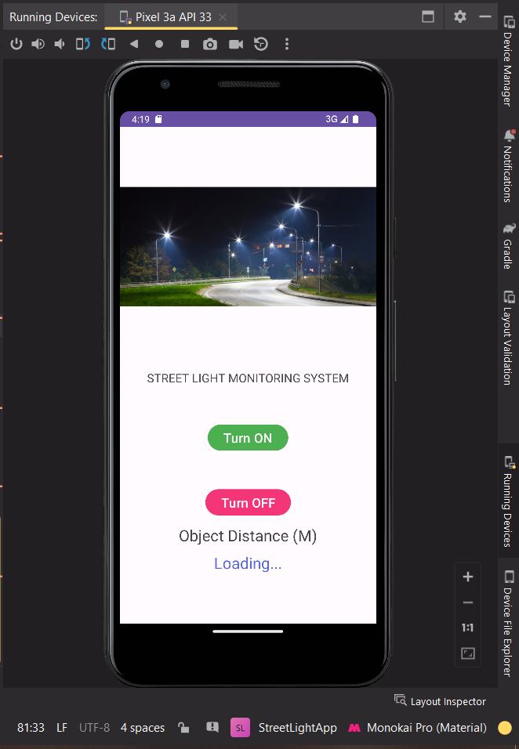 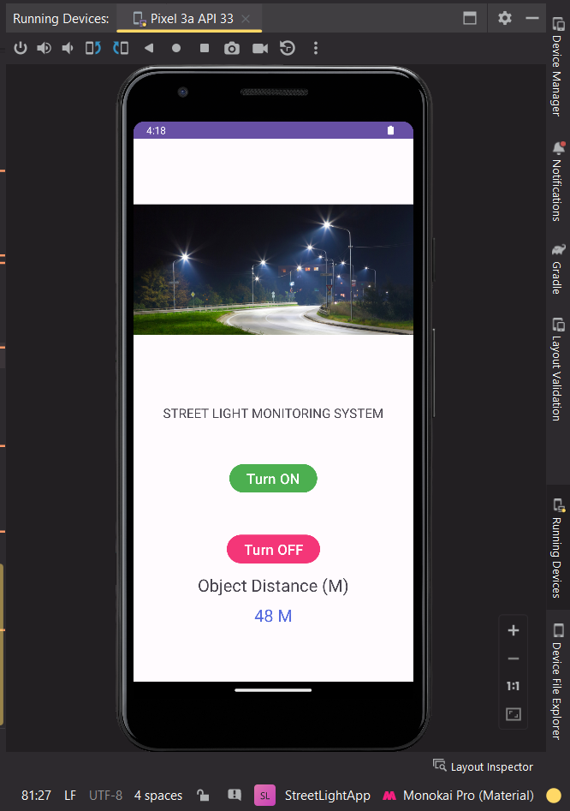

# Performance Test

This is a crucial section that explains why this study is intended for actual enterprises rather than being merely an academic undertaking.

We must first identify the restrictions in this case.

How were those restrictions considered in your design?

What were the test results related to those restrictions?

Memory, MIPS (speed, operations per second), precision, durability, power consumption, and other factors can all be constraints.

If you were unable to test them, you should nonetheless explain how the detected constraints might affect your design and offer suggestions for how to deal with them.

## Test Plan/ Test Cases

Test Objective: To ensure the street light monitoring system with distance sensors functions correctly and efficiently.

Test Environment: Simulated street environment with distance sensors, street lights, and monitoring software.

Test Scope: The test will cover the following aspects of the system:

* Proper functioning of distance sensors.
* Accurate data transmission from distance sensors to the monitoring software.
* Correct switching ON/OFF of street lights based on the proximity of objects (e.g., pedestrians, vehicles).
* System performance under different lighting conditions (day/night).

Test Cases:

1. Test Case: Distance Sensor Calibration
   * Description: Check if the distance sensors are calibrated correctly.
   * Steps:
     1. Place an object at a known distance from the sensor.
     2. Verify if the sensor reading matches the expected distance.
   * Expected Outcome: Sensor reading matches the known distance within an acceptable tolerance.
2. Test Case: Distance Data Transmission
   * Description: Ensure the distance data is accurately transmitted to the monitoring software.
   * Steps:
     1. Create a test scenario with various objects at different distances from the sensors.
     2. Verify if the data is correctly sent to the monitoring software.
   * Expected Outcome: Data is transmitted accurately, and there are no data discrepancies.
3. Test Case: Street Light Activation - Object Detection
   * Description: Test the street light activation based on objects detected by the distance sensors.
   * Steps:
     1. Place an object within the predefined proximity range of the distance sensor.
     2. Check if the corresponding street light turns ON.
   * Expected Outcome: Street light turns ON when an object is detected within the proximity range.
4. Test Case: Street Light Deactivation - No Object Detected
   * Description: Test the street light deactivation when no objects are detected nearby.
   * Steps:
     1. Ensure there are no objects within the proximity range of the distance sensor.
     2. Check if the corresponding street light turns OFF.
   * Expected Outcome: Street light turns OFF when no objects are detected within the proximity range.
5. Test Case: System Response in Different Lighting Conditions
   * Description: Test the system's response during day and night conditions.
   * Steps:
     1. Simulate daytime lighting conditions.
     2. Verify the street light behavior when objects are detected.
     3. Simulate nighttime lighting conditions.
     4. Repeat the verification of street light behavior.
   * Expected Outcome: Street lights function appropriately and adapt to different lighting conditions.

## Test Procedure

1. Set up the test environment with distance sensors, street lights, and the monitoring software.
2. Calibrate the distance sensors to ensure accurate measurements.
3. Execute each test case as per the defined steps.
4. Record the actual results and any deviations or issues encountered.
5. If any issues are found, document them with detailed steps to reproduce.
6. Conduct multiple test iterations to validate the consistency of the results.

## Performance Outcome

1. All test cases should pass without any critical failures.
2. The distance sensors should provide accurate readings within an acceptable tolerance.
3. Data transmission to the monitoring software should be reliable and without any data discrepancies.
4. Street lights should turn ON and OFF correctly based on object detection by distance sensors.
5. The system should respond appropriately under different lighting conditions, ensuring efficient energy consumption.

Note: This test plan is a basic outline and may need further refinement based on the specific requirements of the street light monitoring system with distance sensors. Additionally, it's essential to consider edge cases and potential real-world scenarios during testing to ensure the system's robustness and reliability.

# My learnings

Several significant lessons can be learned from the description of the "Street Light Monitoring System" with a distance sensor:

Internet of Things (IoT) Applications:

The project emphasises how IoT ideas are used in practical situations. The street light system may gather data and make informed judgements to optimise street light operations by using sensors like distance sensors.

Energy Efficiency:

Energy-efficient solutions can be achieved by implementing distance sensors. When there is no activity or traffic, street lights can be dimmed or turned off to save energy, which has a good influence on the environment and lowers costs.

Automation and Control:

On the basis of real-time data, the project's automation and control systems can modify street lighting. Automation lessens the need for manual intervention by enabling faster and more precise reactions to changing situations.

Safety and Public Services:

For the protection and safety of the public, street illumination is essential. The system can ensure that the proper lighting levels are maintained to improve pedestrian and vehicular safety by monitoring the environment with distance sensors.

Data-Driven Decision Making:

The initiative serves as an illustration of the value of data-driven decision making. The system may react dynamically to various scenarios by analysing data from the distance sensor, which increases its adaptability and responsiveness.

Interdisciplinary Nature of Projects:

This type of research combines several academic fields, including software development, electronics, sensors, data processing, and communication protocols. Collaboration between these disciplines is crucial for a project's successful execution.

Environmental Impact:

The project helps to reduce the environmental impact by better managing lights and consuming less electricity. This serves as an example of how technology may contribute to sustainability efforts.

Real-World Application:

The project is an illustration of how technology may be used effectively in daily life. It serves as an example of how innovations can be used to enhance current infrastructure and systems.

Challenges and Limitations:

Despite the various advantages that distance sensors can provide, there may be problems with sensor accuracy, data interpretation, and potential false positives and false negatives. Careful calibration and testing are necessary in order to address these issues.

# Future work scope

Future Scope:

The initiative might serve as a catalyst for additional advancements and upgrades to street lighting systems. For example, adding more sensors, such as motion detectors or cameras, could improve the system's functionality and enable even greater monitoring and control.

All things considered, the "Street Light Monitoring System" with a distance sensor is a useful illustration of how technology may be used to provide smarter, more effective, and long-lasting solutions for public infrastructure. It also emphasises how crucial it is for technical advancements to take societal and environmental repercussions into account.